A

Mini Project Report On

**“Automated Decision Making in Airport Checkpoints Bias Detection toward Smarter Security and Fairness”**

Submitted to JNTUH in partial fulfillment of the Requirements for the award of the Degree of

**BACHELOR OF TECHNOLOGY**

In

**COMPUTER SCIENCE & ENGINEERING**

By

**MD ZAHEER UDDIN 21N61A0550**

Under the Guidance of

**Mrs. RANGU APOORVA**

**Assistant Professor**



**DEPARTMENT OF COMPUTER SCIENCE AND ENGINEERING**

**VIVEKANANDA INSTITUTE OF TECHNOLOGY AND SCIENCE**

(Approved by AICTE New Delhi & Affiliated to JNTU, Hyderabad

**An ISO 9001:2015 certified Institute)**

**KARIMNAGAR-505501**

**2024-2025**

**VIVEKANANDA INSTITUTE OF TECHNOLOGY & SCIENCE(N6)**

(Approved by AICTE New Delhi & Affiliated to JNTU, Hyderabad)

**An ISO 9001:2015 Certified Institution**

**KARIMNAGAR-505001**

**CERTIFICATE**



This is to certify that the mini-project report titled “**Automated Decision Making in Airport Checkpoints Bias Detection toward Smarter Security and Fairness”** is being submitted by **MD ZAHEER UDDIN 21N61A0550** in B. Tech IV-I semester, Computer Science & Engineering is a record bonafide work carried out by him. The results embodied in this report have not been submitted to any other University for the award of any degree.

|  |  |  |  |  |  |  |
| --- | --- | --- | --- | --- | --- | --- |
| **Internal Guide** | **Head of the Department** | | | | | |
| **Mrs. Rangu Apoorva** | **Dr. M. V. Hanumantha Reddy** | | | | | |
|  |  |  |  |  |  |  |
| **External Examiner** |  |  |  |  |  |
|  |  |  |  |  |  |
|  |  |  |  |  |  |  |

### VIVEKANANDA INSTITUTE OF TECHNOLOGY & SCIENCE

(Approved by AICTE New Delhi & Affiliated to JNTU, Hyderabad)

**An ISO 9001:2015 Certified Institution**

**KARIMNAGAR-505501**

#### DEPARTMENT OF COMPUTER SCIENCE AND ENGINEERING

**DECLARATION**



I **MD ZAHEER UDDIN ,21N61A0539** by declare that the Project report entitled

#### “Automated Decision Making in Airport Checkpoints Bias Detection toward Smarter Security and Fairness” submitted in partial fulfillment of the requirements for the award of degree in B. Tech IV-I semester, Computer Science & Engineering This is a record bonafide work carried out me. The results embodied in this report have not been submitted to any other University for the award of any degree or diploma.

MD ZAHEER UDDIN

21N61A0550

DEPARTMENT OF COMPUTER SCIENCE AND ENGINEERING

VIVEKANANDA INSTITUTE OF TECHNOLOGY & SCIENCE, Karimnagar.

**ACKNOWLEDGEMENT**

We would like to express our sincere gratitude to our guide, **Mrs. Rangu Apoorva Assistant Professor**  whose knowledge and guidance has motivated us to achieve goals we never thought possible. She has consistently been a source of motivation, encouragement, and inspiration. The time we have spent working under her supervision has truly been a pleasure.

We thank our H.O.D **Dr. M.V. Hanumanthareddy** for his effort and indefatigable guidance rendered throughout the progress of project work.

Thanks to programmers and nonteaching staff of CSE Department of VITS(N6).

Finally, Special thanks to our parents for their support and encouragement throughout this course. And thanks to our friends and well wishers for their constant support.

**MD ZAHEER UDDIN**

**21N61A0550**

**ABSTRACT**

Automated decision making emerges as the enabler for risk-based and smarter security. However, ethics, privacy, and the General Data Protection Regulation (GDPR) provide a very challenging setting along with monitoring fairness and bias detection when applying artificial intelligence (AI) security solutions.

Ensuring adherence to ethical standards, particularly in the realms of privacy and consent, is critical to maintaining public trust. Additionally, implementing mechanisms to monitor and mitigate biases within AI models is paramount to fairness and equity in security applications.

To address these challenges, organizations must integrate comprehensive frameworks that emphasize transparency and accountability in AI deployment. This includes clear documentation of decision-making processes and the underlying data used, which will help in building trust with stakeholders. Furthermore, adopting robust methods for bias detection and constantly reviewing AI systems for unintended biases will contribute to more equitable outcomes. Balancing the innovative potential of AI with ethical considerations and regulatory compliance is essential for sustainable and responsible security solutions.

To further strengthen AI-driven security solutions, organizations should invest in advanced AI ethics training for their development teams. This includes creating awareness on the importance of ethical AI use and how to integrate ethical considerations throughout the AI lifecycle. By fostering a culture of ethics and continuous learning, organizations can better navigate the complexities of automated decision-making. Additionally, collaboration with regulatory bodies and industry standards organizations can help ensure that AI security solutions are compliant with current and evolving guidelines. This proactive approach not only enhances security but also builds a foundation of trust and confidence among users and stakeholders.

**INDEX**

**CHAPTER 1 PAGE NO**

**INTRODUCTION 1**

1.1 Introduction 1

1.2 Existing System 3

1.3 Disadvantages of Existing System 3

1.4 Proposed System 4

1.5 Advantages of Proposed System 4

# CHAPTER 2

**PRELIMINARY INVESTIGATION 5**

2.1 System Design 5

2.2 Literature Survey 6

**CHAPTER 3**

**SYSTEM REQUIREMENTS SPECIFICATIONS 7**

3.1 Hardware Requirements 7

3.2 Software Requirements 7

3.3 Feasibility Study 8

**CHAPTER 4**

**DESIGN METHODOLOGY 9**

4.1 Architecture Diagram 9

4.2 Dataflow Diagram 10

4.3 UML Diagrams 11

**CHAPTER 5**

**IMPLEMENTATION METHODOLOGY 15**

### CHAPTER 6 SOFTWARE ENVIRONMENT 16

6.1 Java Technology 16

6.2 ODBC 22

6.3 JDBC 24

6.4 Network Concept 27

6.5 J2ME 29

6.6 Tomcat Server 32

### CHAPTER 7 TESTING STRATEGY 34

7.1 Testing 34

7.2 User Training 38

7.3 Maintenance 38

**CHAPTER 8 OUTPUT SCREENS 41 CHAPTER 9 CONCLUSION 50 CHAPTER 10 REFERENCES 51**

**LIST OF FIGURES**

**CONTENTS PAGENO**

Fig: 4.1 Architecture Diagram 9

Fig: 4.3.1 USE CASE Diagram 11

Fig: 4.3.2 Class Diagram 12

Fig: 4.3.3 Sequence Diagram 13

Fig: 6.1 Java Programming Structure 16

Fig: 6.1.2 Java Compiler CAN Run Any Where 17

Fig: 6.1.3 Java Platform Diagram 18

Fig: 6.1.4 Java SDK 20

Fig: 6.3.1 Java Overview 26

Fig: 6.5.1 J2ME Architecture 30

Fig: 6.6.1 Apache Tomcat 7.0 32

Fig: 8.1 Home Screen Login 41

Fig: 8.2 Admin Login 42

Fig: 8.3 View and Authorize Details 43

Fig: 8.4 Add Filter Details 44

Fig: 8.5 View Passenger Name Record 45

Fig: 8.6 View Luggage Tracking Details 46

Fig: 8.7 Register 47

Fig: 8.8 End User Login 48

Fig: 8.7 Add Travelling Details 49

**1. INTRODUCTION**

Risk-based security (RBS) is a trend currently brought up often in numerous research and development programs across the globe, especially in the context of border crossing, where traveler satisfaction and experience are put to the test in long security lines and annoying checks, pat-downs, or the occasional hands-up posing on backscatter X-ray machines. The airport security checkpoint collects and deploys the latest and most efficient tactics in security border control procedures, given the actual but also emblematic role of the airplane as a transland and transocean mode of transport for millions of passengers. Given the impact connected to a highly prestigious target, what seems annoying for some passengers is also widely accepted by the vast majority as necessary and even comforting just to know it is there.

In this security context, RBS states a seemingly attractive case where security can be focused on fewer people in an intelligent way instead of “harassing” the vast majority of harmless passengers and travelers. Following the U.S. Department of Homeland Security’s Transportation Security Administration’s much criticized behavior and personality analysis programs, RBS and behavior analysis have now become a much more mainstream research topic and are handled through numerous initiatives. Part of the International Air Transport Association/Airports Council International (IATA/ACI) former Checkpoint of the Future recommendations— now Smart Security—RBS in airport security checkpoints is the main topic of research for the ongoing H2020 FLYSEC project, which is funded by the European Commission.

With apparent benefits to the efficiency and performance of security controls, RBS is equally sullied, if not overshadowed, by the concerns and threats to privacy, ethics, and fundamental values. Differentiating one passenger from another can be immediately followed by the frustration of the person being in the worst side of the “bargain.” If discrimination is imposed, e.g., based on race, gender, or religious beliefs, then aviation security will have to face costs in terms of ethics and human values that will also be translated to financial losses given the poor passenger experience, not to mention potential lawsuits. In fact, the emotional impact and cost of people feeling discriminated against are both so high that RBS not only has to be fair and ethical but also perceived as such to passengers.

In this article, we investigate the potentials of automated security decision making in terms of operational and technological opportunities, evaluating the threats and implications according to the latest privacy and ethical framework, given also the recent GDPR release.

In particular, we focus on data mining and machine-learning applications and relevant risks, also proposing an expert system capable of analyzing fairness and detecting deviations that might potentially lead to discrimination and violations of human rights.

**RBS Concept**

RBS is, in fact, not a new practice. Human operators and screeners at border control have always been practicing RBS. Many attacks have been avoided in the past due to training and experience as well as the gut feeling of security personnel who just spotted someone behaving oddly amid the crowd. However, with the latest intelligent surveillance and analytics technology developments, RBS comes into the picture as an innovative end-to-end operational and technical framework. Through advancements in AI and mainly through the application of machine learning, security professionals have greatly augmented their capability of analyzing data concerning the behavior and profile patterns of attackers, both in terms of volume of data and availability of sources, including a wide range of national and international law enforcement authorities’ data bases , passenger name records (PNR), and open source web intelligence to name a few.

### 1.2 Existing System

* As profiling and automated processing of information emerge as enablers for more efficient, risk-based and smarter security, growing concerns on ethics and privacy are reflected on the adapting regulatory and legal framework
* In this context and by examining the airport checkpoint as the most challenging and regulated security case system implemented a solution monitoring the fairness of intelligent Manual surveillance systems of an airport and any critical infrastructure. The embedded algorithms receive input from distributed sensors and high-level information and infer suspicious incidents and visitors’ trustfulness level.
* However, the system may result in biased conclusions because of biased sources and/or algorithms. Consequently, we suggest a bias detection system, which exploits a structured representation of Legal regulations, and compare them to association rules extracted by the input and output datasets.

### 1.3 Disadvantages of Existing system

* The System is very less security lack of the General Data Protection Regulation (GDPR).
* The System is Manual.

### 1.4 Proposed System

* In the proposed system, the system investigates the potentials of automated security decision making in terms of operational and technological opportunities, evaluating the threats and implications according to the latest privacy and ethical framework, given also the recent GDPR release.
* In particular, the system focuses on data mining and machine-learning applications and relevant risks, also proposing an expert system capable of analyzing fairness and detecting deviations that might potentially lead to discrimination and violations of human rights.

### 1.5 Advantages of Proposed System

* The system is automated due to GDPR.
* The system is an effective by automated trace of passenger behaviors.

**2.PRELIMINARY INVESTIGATION**

**2.1 System Design**

### Input design

Input Design plays a vital role in the life cycle of software development, it requires very careful attention of developers. The input design is to feed data to the application as accurate as possible. So inputs are supposed to be designed effectively so that the errors occurring while feeding are minimized. According to Software Engineering Concepts, the input forms or screens are designed to provide to have a validation control over the input limit, range and other related validations.

This system has input screens in almost all the modules. Error messages are developed to alert the user whenever he commits some mistakes and guides him in the right way so that invalid entries are not made. Let us see deeply about this under module design.

Input design is the process of converting the user created input into a computer-based format. The goal of the input design is to make the data entry logical and free from errors. The error is in the input are controlled by the input design. The application has been developed in user-friendly manner. The forms have been designed in such a way during the processing the cursor is placed in the position where must be entered. The user is also provided with in an option to select an appropriate input from various alternatives related to the field in certain cases.

Validations are required for each data entered. Whenever a user enters an erroneous data, error message is displayed and the user can move on to the subsequent pages after completing all the entries in the current page.

### Output design

The Output from the computer is required to mainly create an efficient method of communication within the company primarily among the project leader and his team members, in other words, the administrator and the clients. The output of VPN is the system which allows the project leader to manage his clients in terms of creating new clients and assigning new projects to them, maintaining a record of the project validity and providing folder level access to each client on the user side depending on the projects allotted to him. After completion of a project, a new project may be assigned to the client. User authentication procedures are maintained at the initial stages itself. A new user may be created by the administrator himself or a user can himself register as a new user but the task of assigning projects and validating a new user rests with the administrator only.

The application starts running when it is executed for the first time. The server has to be started and then the internet explorer in used as the browser. The project will run on the local area network so the server machine will serve as the administrator while the other connected systems can act as the clients. The developed system is highly user friendly and can be easily understood by anyone using it even for the first time.

**3. SYSTEM REQUIREMENT SPECIFICATION**

### 3.1 Hardware Requirements:

### 

➢ Processor - Pentium –IV

➢ RAM - 4 GB (min)

➢ Hard Disk - 20 GB

➢ Key Board - Standard Windows Keyboard

➢ Mouse - Two or Three Button Mouse

➢ Monitor - SVGA

**3.2 Software Requirements:**

* Operating System - Windows XP
* Coding Language - Java/J2EE(JSP,Servlet)
* Front End - J2EE
* Back End - MySQL

### 3.3 Feasibility Study

An important outcome of preliminary investigation is the determination that the system request is feasible. This is possible only if it is feasible within limited resource and time. The different feasibilities that have to be analyzed are

* **Operational Feasibility**
* **Economic Feasibility**
* **Technical Feasibility**

###### **Operational Feasibility**

Operational Feasibility deals with the study of prospects of the system to be developed. This system operationally eliminates all the tensions of the Admin and helps him in effectively tracking the project progress. This kind of automation will surely reduce the time and energy, which previously consumed in manual work. Based on the study, the system is proved to be operationally feasible.

**Economic Feasibility**

Economic Feasibility or Cost-benefit is an assessment of the economic justification for a computer based project. As hardware was installed from the beginning & for lots of purposes thus the cost on project of hardware is low. Since the system is a network based, any number of employees connected to the LAN within that organization can use this tool from at anytime. The Virtual Private Network is to be developed using the existing resources of the organization. So the project is economically feasible.

###### **Technical Feasibility**

According to Roger S. Pressman, Technical Feasibility is the assessment of the technical resources of the organization. The organization needs IBM compatible machines with a graphical web browser connected to the Internet and Intranet. The system is developed for platform Independent environment. Java Server Pages, JavaScript, HTML, SQL server and WebLogic Server are used to develop the system. The technical feasibility has been carried out. The system is technically feasible for development and can be developed with the existing facility.

**4. DESIGN METHODOLOGY**

### 4.1 Architecture Diagram

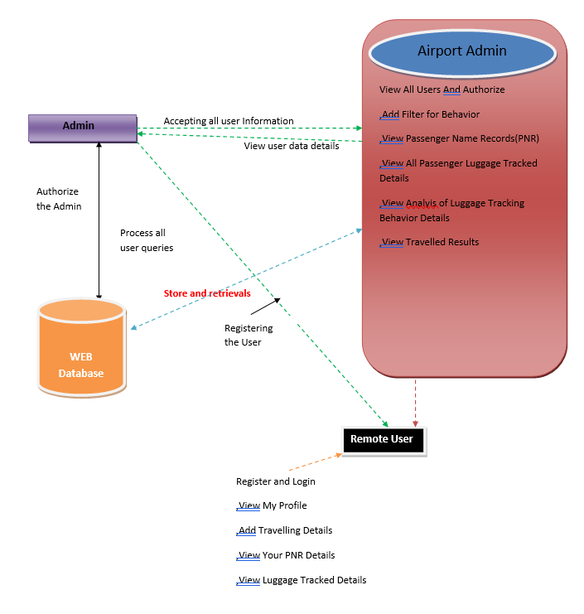

Fig: 4.1 Architecture Diagram

### 4.2 Dataflow Diagram

1. The DFD is also called as bubble chart. It is a simple graphical formalism that can be used to represent a system in terms of input data to the system, various processing carried out on this data, and the output data is generated by this system.
2. The data flow diagram (DFD) is one of the most important modeling tools. It is used to model the system components. These components are the system process, the data used by the process, an external entity that interacts with the system and the information flows in the system.
3. DFD shows how the information moves through the system and how it is modified by a series of transformations. It is a graphical technique that depicts information flow and the transformations that are applied as data moves from input to output.
4. DFD is also known as bubble chart. A DFD may be used to represent a system at any level of abstraction. DFD may be partitioned into levels that represent increasing information flow and functional detail.

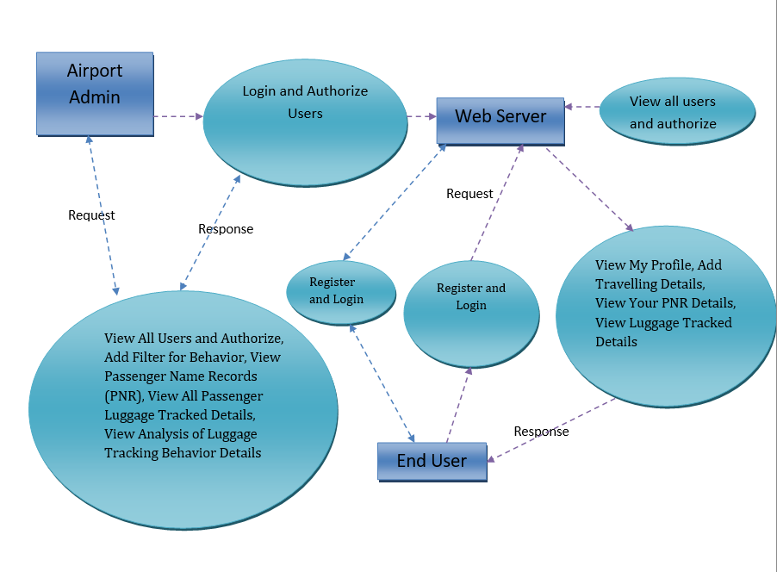

### 4.3 UML Diagrams

UML stands for Unified Modeling Language. UML is a standardized general-purpose modeling language in the field of object-oriented software engineering. The standard is managed, and was created by, the Object Management Group.

The goal is for UML to become a common language for creating models of object oriented computer software. In its current form UML is comprised of two major components: a Metamodel and a notation. In the future, some form of method or process may also be added to; or associated with, UML.

The Unified Modeling Language is a standard language for specifying, Visualization, Constructing and documenting the artifacts of software system, as well as for business modeling and other non-software systems.

The UML represents a collection of best engineering practices that have proven successful in the modeling of large and complex systems.

The UML is a very important part of developing objects oriented software and the software development process. The UML uses mostly graphical notations to express the design of software projects.

**GOALS:**

The Primary goals in the design of the UML are as follows:

1. Provide users a ready-to-use, expressive visual modeling Language so that they can develop and exchange meaningful models.
2. Provide extendibility and specialization mechanisms to extend the core concepts.
3. Be independent of particular programming languages and development process.
4. Provide a formal basis for understanding the modeling language.
5. Encourage the growth of OO tools market.
6. Support higher level development concepts such as collaborations, frameworks, patterns and components.
7. Integrate best practices.

**USE CASE DIAGRAM:**

A use case diagram in the Unified Modeling Language (UML) is a type of behavioral diagram defined by and created from a Use-case analysis. Its purpose is to present a graphical overview of the functionality provided by a system in terms of actors, their goals (represented as use cases), and any dependencies between those use cases. The main purpose of a use case diagram is to show what system functions are performed for which actor. Roles of the actors in the system can be depicted.

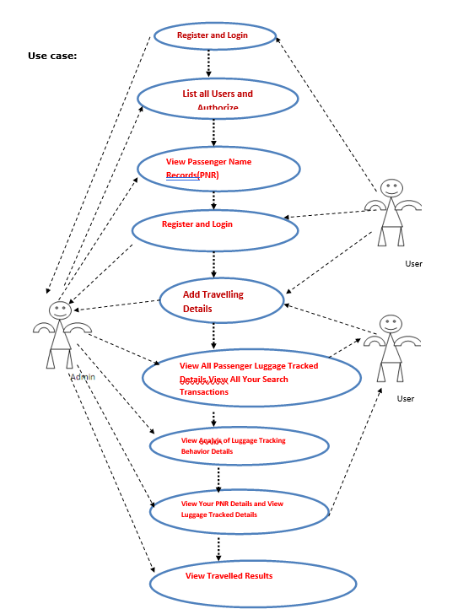

Figure 1Fig: 4.3.1 USE CASE DIAGRAM

**CLASS DIAGRAM:**

In software engineering, a class diagram in the Unified Modeling Language (UML) is a type of static structure diagram that describes the structure of a system by showing the system's classes, their attributes, operations (or methods), and the relationships among the classes. It explains which class contains information.

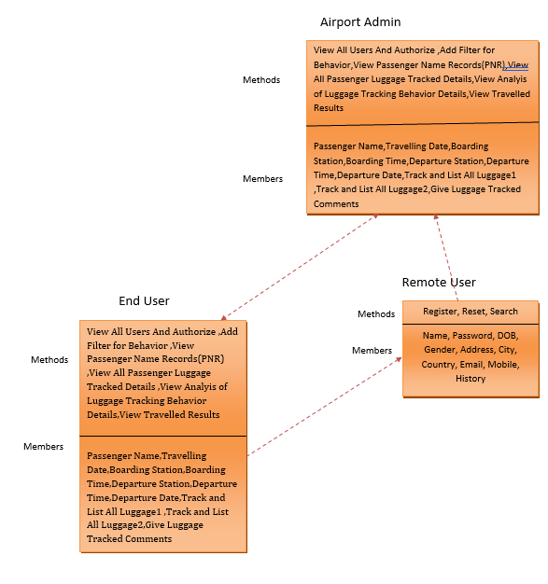

Fig: 4.3.2 CLASS DIAGRAM

**SEQUENCE DIAGRAM:**

A sequence diagram in Unified Modeling Language (UML) is a kind of interaction diagram that shows how processes operate with one another and in what order. It is a construct of a Message Sequence Chart. Sequence diagrams are sometimes called event diagrams, event scenarios, and timing diagrams.

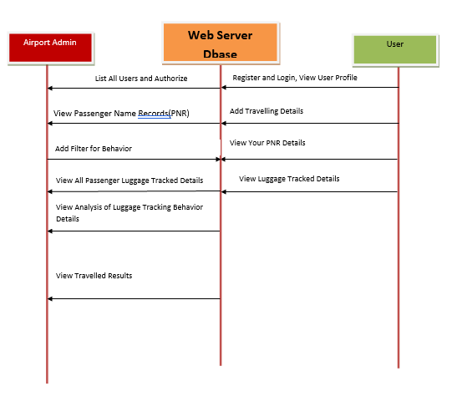

Fig: 4.3.3 SEQUENCE DIAGRAM

**5.IMPLEMENTATION METHODOLOGY**

Implementation is the stage of the project when the theoretical design is turned out into a working system. Thus, it can be considered to be the most critical stage in achieving a successful new system and in giving the user, confidence that the new system will work and be effective. The implementation stage involves careful planning, investigation of the existing system and it’s constraints on implementation, designing of methods to achieve changeover and evaluation of changeover methods. Implementation is the process of converting a new system design into option.

It is the phase that focuses on user training, site preparation and file conversion for installing a candidate system. The important factor that should be considered here is that the conversion should not disrupt the functioning of the organization.

The application is implemented in the Internet Information Services 5.0 web server under the windows 2000 Professional and accessed from various clients. An analysis of user training focuses on two factors

* User capabilities
* Nature of the system

Users range from the native to highly sophisticated. Hence they should be trained about the usage of software. The user should takes care to see that in the event of interruption due to power failure.

# 6. SOFTWARE ENVIRONMENT

## 6.1 JAVA TECHNOLOGY

Java technology is both a programming language and a platform.

The Java programming language is a high-level language that can be characterized by all of the following buzzwords:

* Simple
* Architecture neutral
* Object oriented
* Portable
* Distributed
* High performance
* Interpreted
* Multithreaded
* Robust
* Dynamic
* Secure

With most programming languages, you either compile or interpret a program so that you can run it on your computer. The Java programming language is unusual in that a program is both compiled and interpreted. With the compiler, first you translate a program into an intermediate language called Java byte codes —the platform-independent codes interpreted by the interpreter on the Java platform. The interpreter parses and runs each Java byte code instruction on the computer. Compilation happens just once; interpretation occurs each time the program is executed. The following figure illustrates how this works.

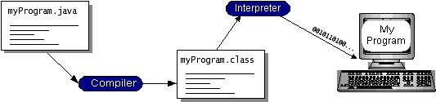

Fig: 6.1 Java Programmig Structure

You can think of Java byte codes as the machine code instructions for the Java Virtual Machine

(Java VM). Every Java interpreter, whether it’s a development tool or a Web browser that can run applets, is an implementation of the Java VM. Java byte codes help make “write once, run anywhere” possible. You can compile your program into byte codes on any platform that has a Java compiler. The byte codes can then be run on any implementation of the Java VM. That means that as long as a computer has a Java VM, the same program written in the Java programming language can run on Windows 2000, a Solaris workstation, or on an iMac.

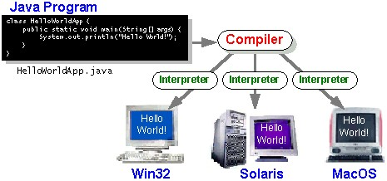

Fig: 6.1.2 Java Compiler Can Run Any Where

### The Java Platform

A platform is the hardware or software environment in which a program runs. We’ve already mentioned some of the most popular platforms like Windows 2000, Linux, Solaris, and MacOS. Most platforms can be described as a combination of the operating system and hardware. The

Java platform differs from most other platforms in that it’s a software-only platform that runs on top of other hardware-based platforms.

The Java platform has two components:

* The Java Virtual Machine (Java VM)
* The Java Application Programming Interface (Java API)

You’ve already been introduced to the Java VM. It’s the base for the Java platform and is ported onto various hardware-based platforms.

The Java API is a large collection of ready-made software components that provide many useful capabilities, such as graphical user interface (GUI) widgets. The Java API is grouped into libraries of related classes and interfaces; these libraries are known as packages.

The following figure depicts a program that’s running on the Java platform. As the figure shows, the Java API and the virtual machine insulate the program from the hardware.

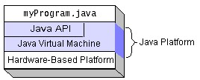

Fig: 6.1.3 Java Platform Diagram

Native code is code that after you compile it, the compiled code runs on a specific hardware platform. As a platform-independent environment, the Java platform can be a bit slower than native code. However, smart compilers, well-tuned interpreters, and just-in-time byte code compilers can bring performance close to that of native code without threatening portability.

**What Can Java Technology Do?**

The most common types of programs written in the Java programming language are applets and applications. If you’ve surfed the Web, you’re probably already familiar with applets. An applet is a program that adheres to certain conventions that allow it to run within a Java-enabled browser.

However, the Java programming language is not just for writing cute, entertaining applets for the Web. The general-purpose, high-level Java programming language is also a powerful software platform. Using the generous API, you can write many types of programs.

An application is a standalone program that runs directly on the Java platform. A special kind of application known as a server serves and supports clients on a network. Examples of servers are Web servers, proxy servers, mail servers, and print servers. Another specialized program is a servlet. A servlet can almost be thought of as an applet that runs on the server side. Java

Servlets are a popular choice for building interactive web applications, replacing the use of CGI scripts. Servlets are similar to applets in that they are runtime extensions of applications. Instead of working in browsers, though, servlets run within Java Web servers, configuring or tailoring the server.

Every full implementation of the Java platform gives you the following features:

**The essentials:**

Objects, strings, threads, numbers, input and output, data structures, system properties, date and time, and so on.

**Applets:**

The set of conventions used by applets.

**Networking:**

URLs, TCP (Transmission Control Protocol), UDP (User Data gram Protocol) sockets, and IP (Internet Protocol) addresses.

**Internationalization:**

Help for writing programs that can be localized for users worldwide. Programs can automatically adapt to specific locales and be displayed in the appropriate language.

**Security:**

Both low level and high level, including electronic signatures, public and private key management, access control, and certificates.

**Software components:**

Known as JavaBeans, can plug into existing component architectures.

**Object serialization:**

Allows lightweight persistence and communication via Remote Method Invocation (RMI).

**Java Database Connectivity (JDBCTM):**

Provides uniform access to a wide range of relational databases.

The Java platform also has APIs for 2D and 3D graphics, accessibility, servers, collaboration, telephony, speech, animation, and more. The following figure depicts what is included in the Java 2 SDK.

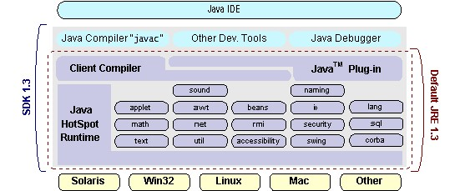

Fig: 6.1.4 Java SDK

**How Will Java Technology Change My Life?**

We can’t promise you fame, fortune, or even a job if you learn the Java programming language. Still, it is likely to make your programs better and requires less effort than other languages. We believe that Java technology will help you do the following:

**Get started quickly:**

Although the Java programming language is a powerful object-oriented language, it’s easy to learn, especially for programmers already familiar with C or C++.

**Write less code:**

Comparisons of program metrics (class counts, method counts, and so on) suggest that a program written in the Java programming language can be four times smaller than the same program in C++.

**Write better code:**

The Java programming language encourages good coding practices, and its garbage collection helps you avoid memory leaks. Its object orientation, its JavaBeans component architecture, and its wide-ranging, easily extendible API let you reuse other people’s tested code and introduce fewer bugs.

**Develop programs more quickly:**

Your development time may be as much as twice as fast versus writing the same program in

C++. Why? You write fewer lines of code and it is a simpler programming language than C++.

**Avoid platform dependencies with 100% Pure Java:**

You can keep your program portable by avoiding the use of libraries written in other languages. The 100% Pure JavaTM Product Certification Program has a repository of historical process manuals, white papers, brochures, and similar materials online.

**Write once, run anywhere:**

Because 100% Pure Java programs are compiled into machine-independent byte codes, they run consistently on any Java platform.

## 6.2 ODBC

Microsoft Open Database Connectivity (ODBC) is a standard programming interface for application developers and database systems providers. Before ODBC became a de facto standard for Windows programs to interface with database systems, programmers had to use proprietary languages for each database they wanted to connect to. Now, ODBC has made the choice of the database system almost irrelevant from a coding perspective, which is as it should be. Application developers have much more important things to worry about than the syntax that is needed to port their program from one database to another when business needs suddenly change.

Through the ODBC Administrator in Control Panel, you can specify the particular database that is associated with a data source that an ODBC application program is written to use. Think of an ODBC data source as a door with a name on it. Each door will lead you to a particular database. For example, the data source named Sales Figures might be a SQL Server database, whereas the Accounts Payable data source could refer to an Access database. The physical database referred to by a data source can reside anywhere on the LAN. The ODBC system files are not installed on your system by Windows 95. Rather, they are installed when you setup a separate database application, such as SQL Server Client or Visual Basic 4.0. When the ODBC icon is installed in Control Panel, it uses a file called ODBCINST.DLL. It is also possible to administer your ODBC data sources through a stand-alone program called ODBCADM.EXE.

From a programming perspective, the beauty of ODBC is that the application can be written to use the same set of function calls to interface with any data source, regardless of the database vendor. The source code of the application doesn’t change whether it talks to Oracle or SQL Server. We only mention these two as an example. There are ODBC drivers available for several dozen popular database systems. Even Excel spreadsheets and plain text files can be turned into data sources. The operating system uses the Registry information written by ODBC Administrator to determine which low-level ODBC drivers are needed to talk to the data source (such as the interface to Oracle or SQL Server). The loading of the ODBC drivers is transparent to the ODBC application program. In a client/server environment, the ODBC API even handles many of the network issues for the application programmer.

The advantages of this scheme are so numerous that you are probably thinking there must be some catch. The only disadvantage of ODBC is that it isn’t as efficient as talking directly to the native database interface. ODBC has had many detractors make the charge that it is too slow.

Microsoft has always claimed that the critical factor in performance is the quality of the driver software that is used. In our humble opinion, this is true. The availability of good ODBC drivers has improved a great deal recently. And anyway, the criticism about performance is somewhat analogous to those who said that compilers would never match the speed of pure assembly language. Maybe not, but the compiler (or ODBC) gives you the opportunity to write cleaner programs, which means you finish sooner. Meanwhile, computers get faster every year*.*

## 6.3 JDBC

In an effort to set an independent database standard API for Java; Sun Microsystems developed Java Database Connectivity, or JDBC. JDBC offers a generic SQL database access mechanism that provides a consistent interface to a variety of RDBMSs. This consistent interface is achieved through the use of “plug-in” database connectivity modules, or drivers. If a database vendor wishes to have JDBC support, he or she must provide the driver for each platform that the database and Java run on.

To gain a wider acceptance of JDBC, Sun based JDBC’s framework on ODBC. As you discovered earlier in this chapter, ODBC has widespread support on a variety of platforms. Basing JDBC on ODBC will allow vendors to bring JDBC drivers to market much faster than developing a completely new connectivity solution.

JDBC was announced in March of 1996. It was released for a 90 day public review that ended

June 8, 1996. Because of user input, the final JDBC v1.0 specification was released soon after. The remainder of this section will cover enough information about JDBC for you to know what it is about and how to use it effectively. This is by no means a complete overview of JDBC.

That would fill an entire book.

#### JDBC Goals

Few software packages are designed without goals in mind. JDBC is one that, because of its many goals, drove the development of the API. These goals, in conjunction with early reviewer feedback, have finalized the JDBC class library into a solid framework for building database applications in Java.

The seven design goals for JDBC are as follows:

##### 1. SQL Level API

The designers felt that their main goal was to define a SQL interface for Java. Although not the lowest database interface level possible, it is at a low enough level for higher-level tools and APIs to be created. Conversely, it is at a high enough level for application programmers to use it confidently. Attaining this goal allows for future tool vendors to “generate” JDBC code and to hide many of JDBC’s complexities from the end user.

##### 2. SQL Conformance

SQL syntax varies as you move from database vendor to database vendor. In an effort to support a wide variety of vendors, JDBC will allow any query statement to be passed through it to the underlying database driver. This allows the connectivity module to handle non-standard functionality in a manner that is suitable for its users.

##### 3. JDBC must be implemental on top of common database interfaces

The JDBC SQL API must “sit” on top of other common SQL level APIs. This goal allows JDBC to use existing ODBC level drivers by the use of a software interface. This interface would translate JDBC calls to ODBC and vice versa.

##### 4. Provide a Java interface that is consistent with the rest of the Java system

Because of Java’s acceptance in the user community thus far, the designers feel that they should not stray from the current design of the core Java system.

##### 5. Keep it simple

This goal probably appears in all software design goal listings. JDBC is no exception. Sun felt that the design of JDBC should be very simple, allowing for only one method of completing a task per mechanism. Allowing duplicate functionality only serves to confuse the users of the API.

##### 6. Use strong, static typing wherever possible

Strong typing allows for more error checking to be done at compile time; also, less error appear at runtime.

##### 7. Keep the common cases simple

Because more often than not, the usual SQL calls used by the programmer are simple

SELECT’s, INSERT’s, DELETE’s and UPDATE’s, these queries should be simple to perform with JDBC. However, more complex SQL statements should also be possible.

Finally, we decided to proceed the implementation using JavaNetworking. And for dynamically updating the cache table we go for MSAccess database.

Java has two things:

* A programming language and a platform.
* Java is a high-level programming language that is all of the following

|  |  |  |  |  |
| --- | --- | --- | --- | --- |
| • | Simple |  | • | Architecture-neutral |
| • | Object-oriented |  | • | Portable |
| • | Distributed |  | • | High-performance |
| • | Interpreted |  | • | multithreaded |
| • | Robust |  | • | Dynamic |
| • | Secure |  |  |  |

Java is also unusual in that each Java program is both compiled and interpreted. With a compile you translate a Java program into an intermediate language called Java byte codes the platform-independent code instruction is passed and run on the computer. Compilation happens just once; interpretation occurs each time the program is executed. The figure illustrates how this works.



**Interpreter**



**Java**

**Program**



**Compilers**



**My Program**

Fig: 6.3.1 Java overview

### 6.4 NETWORK CONCEPTS

#### TCP/IP stack

The TCP/IP stack is shorter than the OSI one:

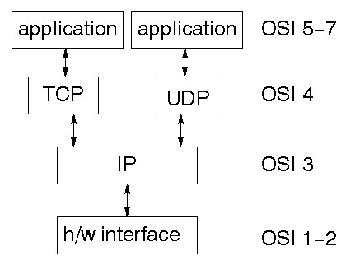

TCP is a connection-oriented protocol; UDP (User Datagram Protocol) is a connectionless protocol.

#### IP datagram’s

The IP layer provides a connectionless and unreliable delivery system. It considers each datagram independently of the others. Any association between datagram must be supplied by the higher layers. The IP layer supplies a checksum that includes its own header. The header includes the source and destination addresses. The IP layer handles routing through an Internet. It is also responsible for breaking up large datagram into smaller ones for transmission and reassembling them at the other end.

#### UDP

UDP is also connectionless and unreliable. What it adds to IP is a checksum for the contents of the datagram and port numbers. These are used to give a client/server model - see later.

#### TCP

TCP supplies logic to give a reliable connection-oriented protocol above IP. It provides a virtual circuit that two processes can use to communicate.

##### Internet addresses

In order to use a service, you must be able to find it. The Internet uses an address scheme for machines so that they can be located. The address is a 32 bit integer which gives the IP address. This encodes a network ID and more addressing. The network ID falls into various classes according to the size of the network address.

##### Network address

Class A uses 8 bits for the network address with 24 bits left over for other addressing. Class B uses 16 bit network addressing. Class C uses 24 bit network addressing and class D uses all 32. **Subnet address**

Internally, the UNIX network is divided into sub networks. Building 11 is currently on one sub network and uses 10-bit addressing, allowing 1024 different hosts.

##### Host Address

8 bits are finally used for host addresses within our subnet. This places a limit of 256 machines that can be on the subnet.

##### Total address

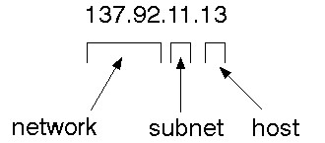

The 32-bit address is usually written as 4 integers separated by dots

##### Port addresses

A service exists on a host, and is identified by its port. This is a 16 bit number. To send a message to a server, you send it to the port for that service of the host that it is running on. This is not location transparency! Certain of these ports are "well known".

##### Sockets

A socket is a data structure maintained by the system to handle network connections. A socket is created using the call socket. It returns an integer that is like a file descriptor. In fact, under Windows, this handle can be used with Read File and Write File functions.

#include <sys/types.h> #include <sys/socket.h>

int socket (int family, int type, int protocol);

Here "family" will be AF_INET for IP communications, protocol will be zero, and type will depend on whether TCP or UDP is used. Two processes wishing to communicate over a network create a socket each. These are similar to two ends of a pipe - but the actual pipe does not yet exist.

## 6.5 J2ME

Sun Microsystems defines J2ME as "a highly optimized Java run-time environment targeting a wide range of consumer products, including pagers, cellular phones, screen-phones, digital settop boxes and car navigation systems." Announced in June 1999 at the JavaOne Developer Conference, J2ME brings the cross-platform functionality of the Java language to smaller devices, allowing mobile wireless devices to share applications. With J2ME, Sun has adapted the Java platform for consumer products that incorporate or are based on small computing devices.

#### 1. General J2ME architecture

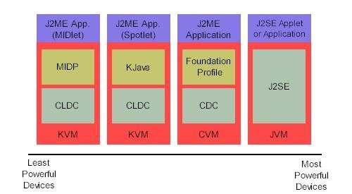

Fig: 6.5.1 J2ME Architecture

J2ME uses configurations and profiles to customize the Java Runtime Environment (JRE). As a complete JRE, J2ME is comprised of a configuration, which determines the JVM used, and a profile, which defines the application by adding domain-specific classes. The configuration defines the basic run-time environment as a set of core classes and a specific JVM that run on specific types of devices. We'll discuss configurations in detail in the profile defines the application; specifically, it adds domain-specific classes to the J2ME configuration to define certain uses for devices. We'll cover profiles in depth in the following graphic depicts the relationship between the different virtual machines, configurations, and profiles.

#### 2. Developing J2ME applications

Introduction In this section, we will go over some considerations you need to keep in mind when developing applications for smaller devices. We'll take a look at the way the compiler is invoked when using J2SE to compile J2ME applications. Finally, we'll explore packaging and deployment and the role preverification plays in this process.

#### 3. Design considerations for small devices

Developing applications for small devices requires you to keep certain strategies in mind during the design phase. It is best to strategically design an application for a small device before you begin coding. Correcting the code because you failed to consider all of the "gotchas" before developing the application can be a painful process. Here are some design strategies to consider:

* Smaller is better. This consideration should be a "no brainer" for all developers. Smaller applications use less memory on the device and require shorter installation times. Consider packaging your Java applications as compressed Java Archive (jar) files.
* Minimize run-time memory use. To minimize the amount of memory used at run time, use scalar types in place of object types. Also, do not depend on the garbage collector.

#### 4. Configuration overview

The configuration defines the basic run-time environment as a set of core classes and a specific JVM that run on specific types of devices. Currently, two configurations exist for J2ME, though others may be defined in the future:

**Connected Limited Device Configuration (CLDC)** is used specifically with the KVM for 16bit or 32-bit devices with limited amounts of memory. This is the configuration (and the virtual machine) used for developing small J2ME applications. Its size limitations make CLDC more interesting and challenging (from a development point of view) than CDC. CLDC is also the configuration that we will use for developing our drawing tool application. An example of a small wireless device running small applications is a Palm hand-held computer.

**Connected Device Configuration (CDC)** is used with the C virtual machine (CVM) and is used for 32-bit architectures requiring more than 2 MB of memory. An example of such a device is a Net TV box.

#### 5. J2ME profiles

**What is a J2ME profile?**

As we mentioned earlier in this tutorial, a profile defines the type of device supported. The Mobile Information Device Profile (MIDP), for example, defines classes for cellular phones. It adds domain-specific classes to the J2ME configuration to define uses for similar devices. Two profiles have been defined for J2ME and are built upon CLDC: KJava and MIDP. Both KJava and MIDP are associated with CLDC and smaller devices. Profiles are built on top of configurations. Because profiles are specific to the size of the device (amount of memory) on which an application runs, certain profiles are associated with certain configurations.

## 6.6 TOMCAT SERVER

Tomcat is an open-source web server developed by Apache Group. Apache Tomcat is the servlet container that is used in the official Reference Implementation for the Java Servlet and Java Server Pages technologies. The Java Servlet and Java Server Pages specifications are developed by Sun under the Java Community Process. Web Servers like Apache Tomcat support only web components while an application server supports web components as well as business components (BEAs WebLogic, is one of the popular application servers).

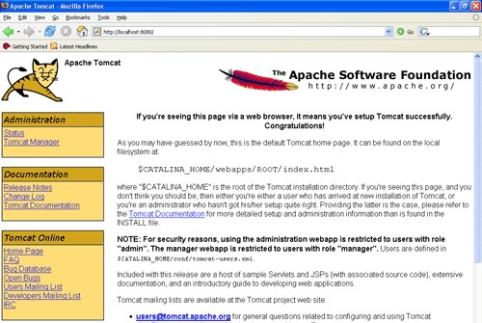

Fig: 6.6.1 Apache Tomcat 7.0

Tomcat's architecture is built upon a modular design, allowing it to function as a standalone server or be integrated seamlessly with other web servers like Apache HTTP Server. Its core components include the Catalina servlet container, which handles the execution of Java Servlets and JSP pages, and the Coyote connector, responsible for managing communication between Tomcat and external clients using various protocols such as HTTP.

**Key Features:**

**Servlet and JSP Support:**

Tomcat provides full support for Java Servlets and Java Server Pages, enabling developers to build dynamic and interactive web applications.

**Open-Source Nature:**

Being open-source, Tomcat is freely available, fostering a vibrant community of developers who contribute to its improvement and ensure its continual evolution.

**Platform Independence:**

Tomcat is platform-independent, making it compatible with various operating systems, including Windows, Linux, and macOS.

**Scalability:**

Tomcat offers scalability, allowing it to efficiently handle a growing number of requests by adding more resources or by clustering multiple Tomcat instances.

**Security Features:**

Security is a top priority for Tomcat, with features such as SSL/TLS support, authentication, and authorization mechanisms, safeguarding web applications from potential threats.

**Management and Monitoring:**

Tomcat includes a web-based management interface, the Tomcat Manager, facilitating easy deployment, undeployment, and monitoring of applications. Additionally, tools like JConsole and JVisualVM can be employed for in-depth performance analysis.

Deploying applications on Tomcat is a straightforward process. Developers can package their applications as WAR (Web Application Archive) files, which can then be deployed to Tomcat using the Tomcat Manager or by placing the WAR files directly into the designated deployment directory.

Apache Tomcat continues to be a stalwart choice for developers seeking a reliable, scalable, and open-source solution for hosting Java web applications.

**7. TESTING AND VALIDATION**

### 7.1 Testing

### TESTING METHODOLOGIES

The following are the Testing Methodologies:

* **Unit Testing.**
* **Integration Testing.**
* **User Acceptance Testing.**
* **Output Testing.**
* **Validation Testing.**

**Unit Testing**

Unit testing focuses verification effort on the smallest unit of Software design that is the module. Unit testing exercises specific paths in a module’s control structure to

ensure complete coverage and maximum error detection. This test focuses on each module individually, ensuring that it functions properly as a unit. Hence, the naming is Unit Testing.

During this testing, each module is tested individually and the module interfaces are verified for the consistency with design specification. All important processing path are tested for the expected results. All error handling paths are also tested.

**Integration Testing**

Integration testing addresses the issues associated with the dual problems of verification and program construction. After the software has been integrated a set of high order tests are conducted. The main objective in this testing process is to take unit tested modules and builds a program structure that has been dictated by design.

**The following are the types of Integration Testing:**

1. **Top Down Integration**

This method is an incremental approach to the construction of program structure. Modules are integrated by moving downward through the control hierarchy, beginning with the main program module. The module subordinates to the main program module are incorporated into the structure in either a depth first or breadth first manner.

In this method, the software is tested from main module and individual stubs are replaced when the test proceeds downwards.

**2. Bottom-up Integration**

This method begins the construction and testing with the modules at the lowest level in the program structure. Since the modules are integrated from the bottom up, processing required for modules subordinate to a given level is always available and the need for stubs is eliminated. The bottom up integration strategy may be implemented with the following steps:

* The low-level modules are combined into clusters into clusters that perform a specific Software sub-function.
* A driver (i.e.) the control program for testing is written to coordinate test case input and output.
* The cluster is tested.
* Drivers are removed and clusters are combined moving upward in the program structure

The bottom up approaches tests each module individually and then each module is module is integrated with a main module and tested for functionality.

**7.1.3 User Acceptance Testing**

User Acceptance of a system is the key factor for the success of any system. The system under consideration is tested for user acceptance by constantly keeping in touch with the prospective system users at the time of developing and making changes wherever required. The system developed provides a friendly user interface that can easily be understood even by a person who is new to the system.

**7.1.4 Output Testing**

After performing the validation testing, the next step is output testing of the proposed system, since no system could be useful if it does not produce the required output in the specified format. Asking the users about the format required by them tests the outputs generated or displayed by the system under consideration. Hence the output format is considered in 2 ways – one is on screen and another in printed format.

**7.1.5 Validation Checking**

Validation checks are performed on the following fields.

**Text Field:**

The text field can contain only the number of characters lesser than or equal to its size. The text fields are alphanumeric in some tables and alphabetic in other tables. Incorrect entry always flashes and error message.

**Numeric Field:**

The numeric field can contain only numbers from 0 to 9. An entry of any character flashes an error messages. The individual modules are checked for accuracy and what it has to perform. Each module is subjected to test run along with sample data. The individually tested modules are integrated into a single system. Testing involves executing the real data information is used in the program the existence of any program defect is inferred from the output. The testing should be planned so that all the requirements are individually tested.

A successful test is one that gives out the defects for the inappropriate data and produces and output revealing the errors in the system.

**Preparation of Test Data**

Taking various kinds of test data does the above testing. Preparation of test data plays a vital role in the system testing. After preparing the test data the system under study is tested using that test data. While testing the system by using test data errors are again uncovered and corrected by using above testing steps and corrections are also noted for future use.

**Using Live Test Data:**

Live test data are those that are actually extracted from organization files. After a system is partially constructed, programmers or analysts often ask users to key in a set of data from their normal activities. Then, the systems person uses this data as a way to partially test the system. In other instances, programmers or analysts extract a set of live data from the files and have them entered themselves.

It is difficult to obtain live data in sufficient amounts to conduct extensive testing. And, although it is realistic data that will show how the system will perform for the typical processing requirement, assuming that the live data entered are in fact typical, such data generally will not test all combinations or formats that can enter the system. This bias toward typical values then does not provide a true systems test and in fact ignores the cases most likely to cause system failure.

**Using Artificial Test Data:**

Artificial test data are created solely for test purposes, since they can be generated to test all combinations of formats and values. In other words, the artificial data, which can quickly be prepared by a data generating utility program in the information systems department, make possible the testing of all login and control paths through the program.

The most effective test programs use artificial test data generated by persons other than those who wrote the programs. Often, an independent team of testers formulates a testing plan, using the systems specifications.

The package “Virtual Private Network” has satisfied all the requirements specified as per software requirement specification and was accepted.

**7.2 USER TRAINING**

Whenever a new system is developed, user training is required to educate them about the working of the system so that it can be put to efficient use by those for whom the system has been primarily designed. For this purpose the normal working of the project was demonstrated to the prospective users. Its working is easily understandable and since the expected users are people who have good knowledge of computers, the use of this system is very easy.

**7.3** **MAINTAINENCE**

This covers a wide range of activities including correcting code and design errors. To reduce the need for maintenance in the long run, we have more accurately defined the user’s requirements during the process of system development. Depending on the requirements, this system has been developed to satisfy the needs to the largest possible extent. With development in technology, it may be possible to add many more features based on the requirements in future. The coding and designing is simple and easy to understand which will make maintenance easier.

**TESTING STRATEGY :**

A strategy for system testing integrates system test cases and design techniques into a well planned series of steps that results in the successful construction of software. The testing strategy must co-operate test planning, test case design, test execution, and the resultant data collection and evaluation .A strategy for software testing must accommodate low-level tests that are necessary to verify that a small source code segment has been correctly implemented as well as high level tests that validate major system functions against user requirements.

Software testing is a critical element of software quality assurance and represents the ultimate review of specification design and coding. Testing represents an interesting anomaly for the software. Thus, a series of testing are performed for the proposed system before the system is ready for user acceptance testing.

**SYSTEM TESTING:**

Software once validated must be combined with other system elements (e.g. Hardware, people, database). System testing verifies that all the elements are proper and that overall system function performance is

achieved. It also tests to find discrepancies between the system and its original objective, current specifications and system documentation.

**UNIT TESTING:**

In unit testing different are modules are tested against the specifications produced during the design for the modules. Unit testing is essential for verification of the code produced during the coding phase, and hence the goals to test the internal logic of the modules. Using the detailed design description as a guide, important Conrail paths are tested to uncover errors within the boundary of the modules. This testing is carried out during the programming stage itself. In this type of testing step, each module was found to be working satisfactorily as regards to the expected output from the module.

In Due Course, latest technology advancements will be taken into consideration. As part of technical build-up many components of the networking system will be generic in nature so that future projects can either use or interact with this.The future holds a lot to offer to the development and refinement of this project.

1. **OUTPUT SCREENS**

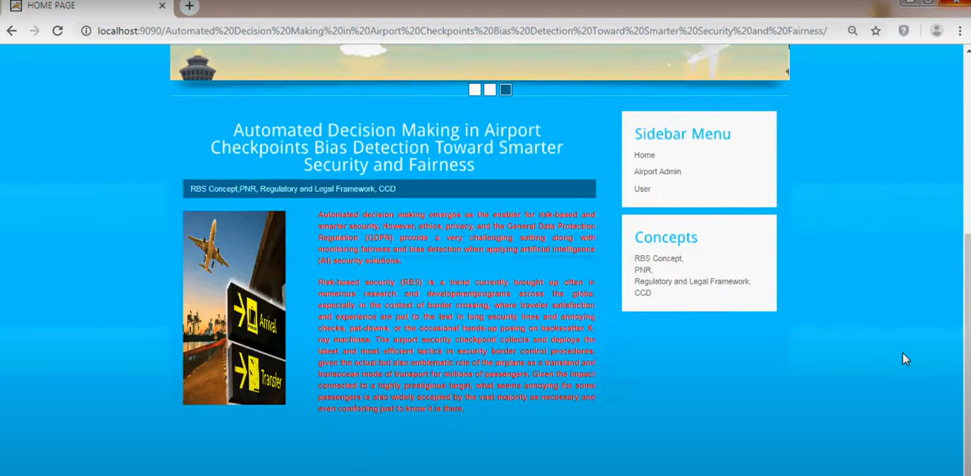

FIGURE 8.1 HOME PAGE LOGIN

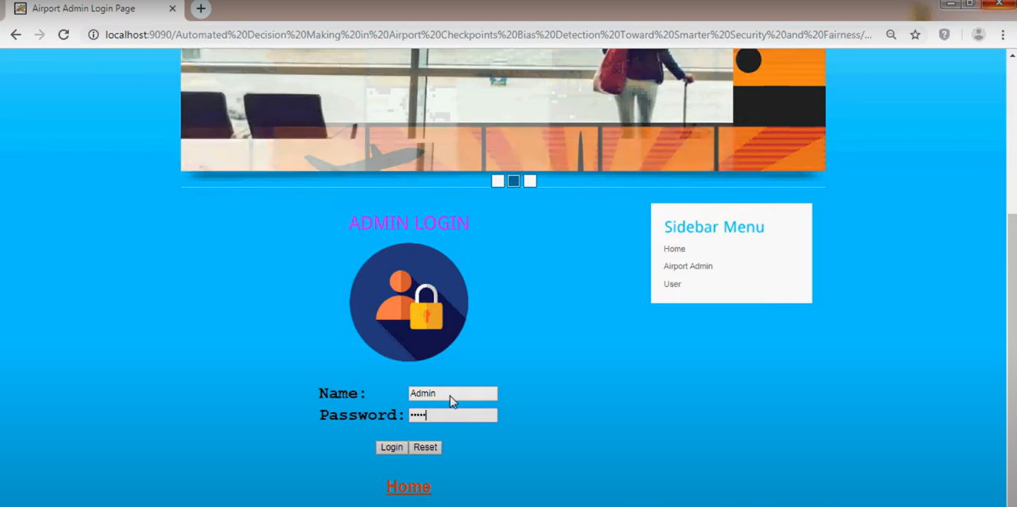

FIGURE 8.2 ADMIN LOGIN

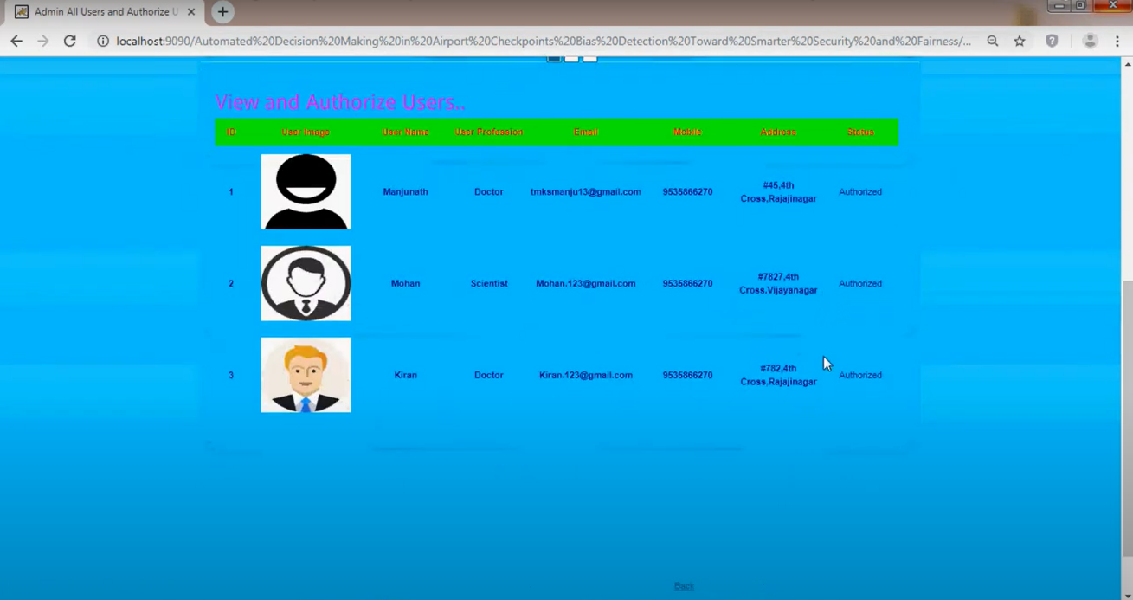

FIGURE 8.3 VIEW AND AUTHORIZE USERS

-

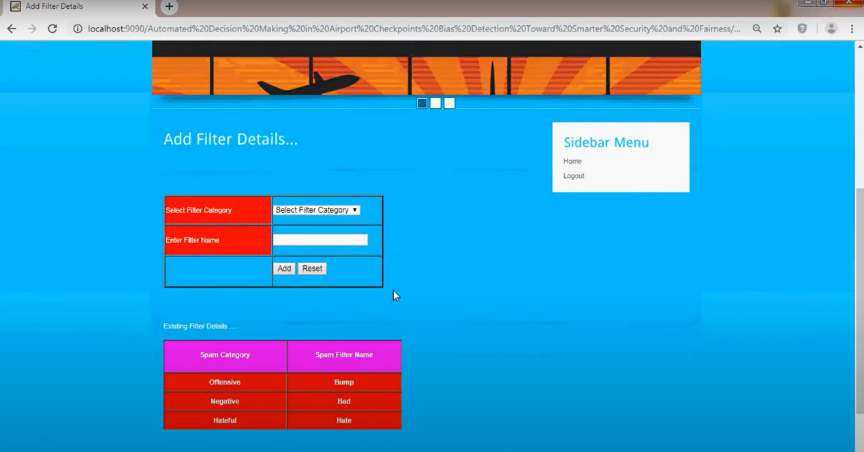

FIGURE 8.4 ADD FILTER DETAILS

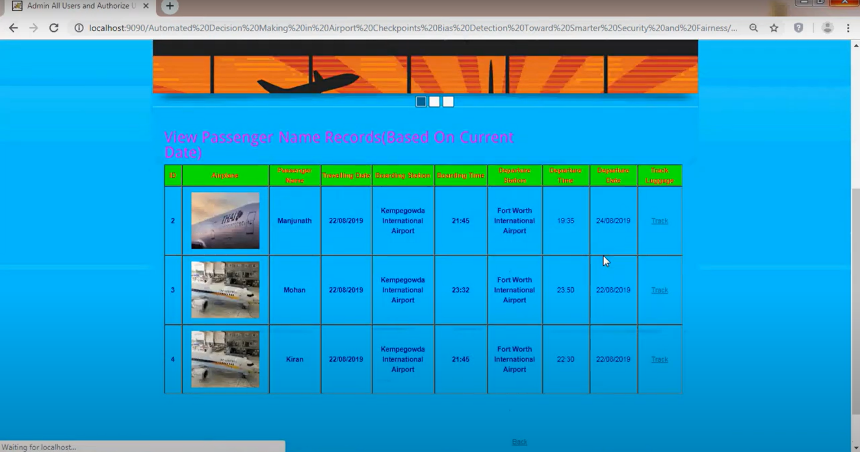

FIGURE 8.5 VIEW PASSANGER NAME RECORDS

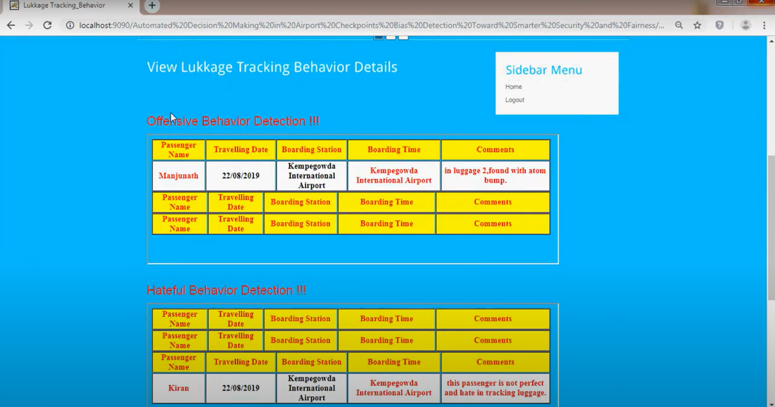

FIGURE 8.6 VIEW LUGGAGE TRACKING BEHAVIOR

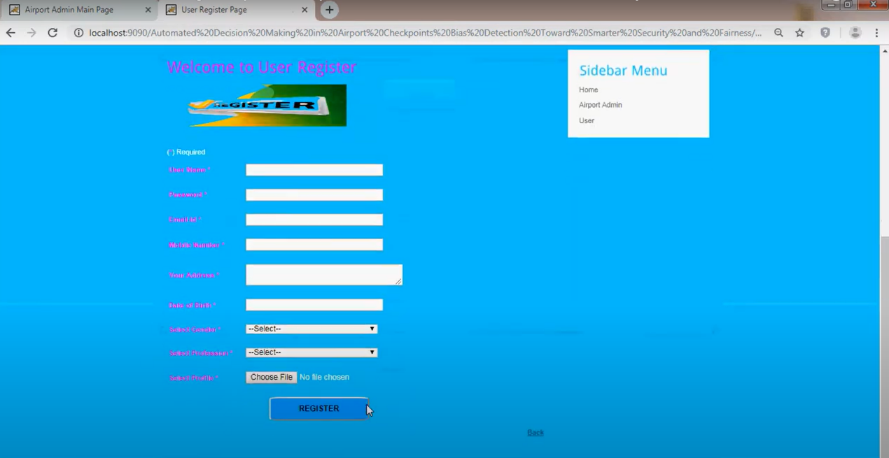

FIGURE 8.7 REGISTER

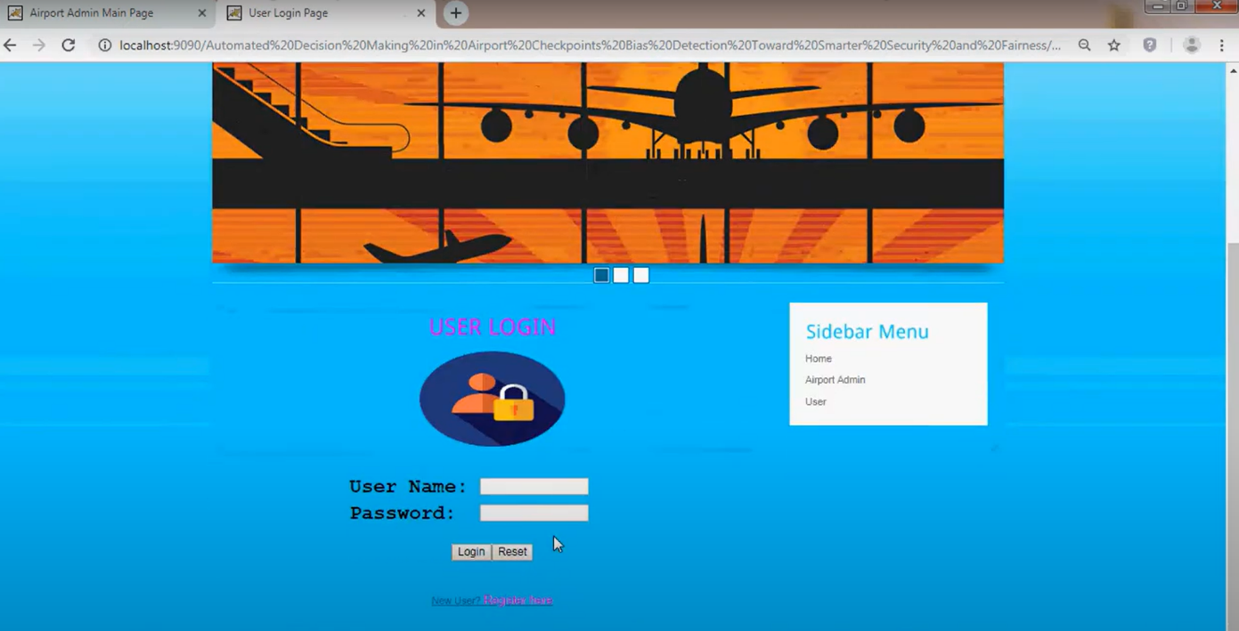

FIGURE 8.8 END USER LOGIN

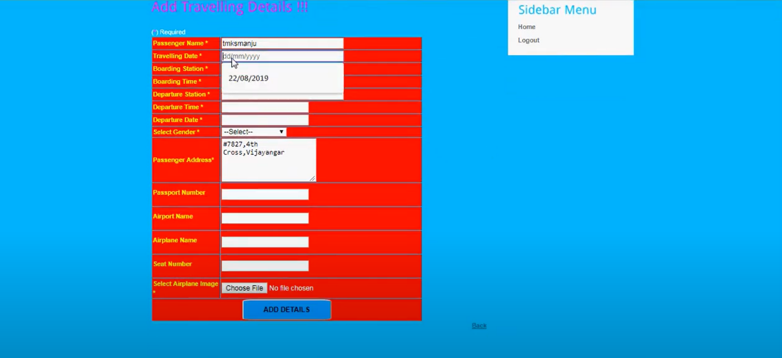

FIGURE 8.9 ADD TRAVELLING DETAILS

1. **CONCLUSION**

The reliability and assimilation of AI technology in security systems require fairness and respecting privacy and ethical regulations. However, intelligent systems rely on knowledge, which usually forms biased AI systems both by design during development and also via training procedures using biased data sets. Significant work has been done regarding the techniques of detecting biases in data sets on specific features and ways of refinements.5, 9, 14 As a complement to this, we suggest a way of incorporating legal regulations in bias detection procedures to target biases of legal importance. Our solution corresponds to a binding of legal unstructured text information and the quantitative algorithmic procedures of automatic AI systems. The outcome of our system is the compliance of the intelligent components of a surveillance system with the legal framework as designed by legal official authorities.

Even if any bias in intelligence systems is successfully detected, the final goal is to alleviate it and restore fairness. Our research aims at the refinement of input data sets to be in compliance with legal frameworks without losing accuracy. However, most of the time, bias in data sets results from the lack of general knowledge about human behavior for all cases of sensitive data. In surveillance systems, the result is that intelligence components can infer potential threats only for specific sensitive data groups that are available, which, of course, is unfair. Our further research focuses on simulation models that enrich intelligence-component-training data sets

with data that are as coherent as possible with the real visitors’ behavior and simultaneously maintaining the compliance of the data set with the legal framework.

1. **REFERENCES**

1. IATA Corporate Communications, “Joint press release:

ACI and IATA collaborate to deliver smart security,” IATA,

Dec. 12, 2013. [Online]. Available: http://www.iata.org

/pressroom/pr/Pages/2013-12-12-02.aspx

2. FLYSEC, “Optimising time-to-FLY and enhancing airport

SECurity project website.” Accessed on: Feb. 20, 2019.

[Online]. Available: http://www.fly-sec.eu.

3. General Data Protection Regulation, “Regulation (EU)

2016/679 of the European Parliament and of the Council.”

Accessed on: Feb. 20, 2019. [Online]. Available:

https://eur-lex.europa.eu/legal-content/EN/TXT/PDF

/?uri=CELEX:32016R0679&from=EN

4. M. Kost and J.-C. Freytag, “Privacy analysis using ontologies,”

*CODASPY’12*, 2012, pp. 205–216.

5. M. B. Zafar, I. Valera, M. G. Rodriguez, K. P. Gummadi,

“Fairness constraints: Mechanisms for fair classification,”

in *Proc. 20th Int. Conf. Artificial Intelligence and Statistics*

*(AISTATS),* 2017, pp. 962–970.

6. A. Albarghouthi, L. D’Antoni, S. Drews, and A. Nori,

“Fairness as a program property,” 2016. [Online]. Available::

https://arxiv.org/abs/1610.06067

7. L. E. Celis, A. Deshpande, T. Kathuria, and N. K. Vishnoi,

“How to be fair and diverse?” 2016. [Online] Available:

https://arxiv.org/abs/1610.07183v1

8. J. L. Skeem and C. T. Lowenkamp, “Risk, race, & recidivism:

Predictive bias and disparate impact,” Social

Science Research Network, Nov. 8, 2015. [Online].

Available: https://papers.ssrn.com/sol3/papers.cfm?

abstract_id=2687339

9. A. Chouldechova, “Fair prediction with disparate impact,”

2016. [Online]. Available: https://arxiv.org/abs/1610.07524v1

10. S. Bird, S. Barocas, K. Crawford, F. Diaz, H. Wallach,

“Exploring or exploiting? Social and ethical implications

of autonomous experimentation in AI,” presented at the

Workshop Fairness, Accountability, and Transparency

Machine Learning, 2016. [Online]. Available: https://

ssrn.com/abstract=2846909

11. S. Hajian, F. Bonchi, and C. Castillo, “Algorithmic bias:

From discrimination discovery to fairness-aware data

mining,” in *Proc. 22nd ACM SIGKDD Int. Conf. Knowledge*

*Discovery and Data Mining*, 2016, pp. 2125–2126.

12. U.S. Equal Employment Opportunity Commision, “Types

of discrimination.” Accessed on: Feb. 20, 2019. [Online].

Available: https://www.eeoc.gov/laws/types.

13. B. Mittelstadt, P. Allo, M. Taddeo, S. Wachter, and L. Floridi,

“The ethics of algorithms: Mapping the debate,” *Big*

*Data Soc.*, vol. 3, 2016. doi:10.1177/2053951716679679

14. I. Zliobaite, “A survey on measuring indirect discrimination

in machine learning,” 2015. [Online]. Available: https://

arxiv.org/abs/1511.00148v1

15. B. Fish, J. Kun, and A. D. Lelkes, “A confidence-based

approach for balancing fairness and accuracy,” 2016.

[Online]. Available: https://arxiv.org/abs/1601.05764v1